Modelling and Pricing Air Pollution Derivatives

Anders D. Sleirea,b

aDepartment of Mathematics, University of Bergen, Bergen, Norway, bTryg Forsikring, Bergen, Norway

Correspondence should be addressed to Anders D. Sleire, Anders.Sleire@uib.no

Introduction 3

Measuring ambient air quality 4

The criteria air pollutants 4

The Air Quality Index 5

Introducing air pollution derivatives 6

Traditional weather derivatives 6

Air pollution derivatives 7

A stochastic air quality model 7

Modelling framework 8

Parameter estimation 8

Derivatives pricing 11

Air pollution index futures 11

Pricing options on air pollution futures 11

Empirical results 11

Data 11

Analysis 11

Conclusions 11

Acknowledgments 11

Modelling and Pricing Air Pollution Derivatives

Type or paste your abstract here as prescribed by the journal’s instructions for authors. Type or paste your abstract here as prescribed by the journal’s instructions for authors. Type or paste your abstract here as prescribed by the journal’s instructions for authors. Type or paste your abstract here. Type or paste your abstract here as prescribed by the journal’s instructions for authors. Type or paste your abstract here as prescribed by the journal’s instructions for authors. Type or paste your abstract here as prescribed by the journal’s instructions for authors. Type or paste your abstract here. Type or paste your abstract here as prescribed by the journal’s instructions for authors. Type or paste your abstract here as prescribed by the journal’s instructions for authors. Type or paste your abstract here as prescribed by the journal’s instructions for authors. Type or paste your abstract here. Type or paste your abstract here as prescribed by the journal’s instructions for authors. Type or paste your abstract here as prescribed by the journal’s instructions for authors. Type or paste your abstract here as prescribed by the journal’s instructions for authors. Type or paste your abstract here.

Keywords: Air pollution derivatives, Stochastic modelling, Ornstein-Uhlenbeck, Lévy processes, Jump diffusion model

Subject classification codes: TBD

# Introduction

Paragraph: use this for the first paragraph in a section, or to continue after an extract.

New paragraph: use this style when you need to begin a new paragraph.

# Measuring ambient air quality

## The criteria air pollutants

Millions of people who live in urban areas are victims of severe air pollution. The degree of contamination is determined by measuring the so-called criteria air pollutants. The measurement units for the criteria air pollutants are micrograms per cubic meter (), parts per million (), and parts per billion .

|  |  |  |
| --- | --- | --- |
| Pollutant | Short name | Measurement unit |
| Ground-level Ozone |  |  |
| Particulate Matter 10 |  |  |
| Particulate Matter 2.5 |  |  |
| Carbon Monoxide |  |  |
| Sulfur Dioxide |  |  |
| Lead |  |  |
| Nitrogen Dioxide |  |  |

Table 1. The US EPA criteria air pollutants.

## The Air Quality Index

|  |  |  |  |  |  |  |  |
| --- | --- | --- | --- | --- | --- | --- | --- |
| **AQI** | **O3 (ppb)** (8-hr) | **O3 (ppb)** (1-hr) | **PM2.5 µg/m3** (24-hr) | **PM10 (µg/m3)** (24-hr) | **CO (ppm)** (8-hr) | **SO2 (ppb)** | **NO2 (ppb)** (1-hr) |
| 0-50 | 0-54 | - | 0.0-12.0 | 0-54 | 0.0-4.4 | 0-35 (1-hr) | 0-53 |
| 51-100 | 55-70 | - | 12.1-35.4 | 55-154 | 4.5-9.4 | 36-75 (1-hr) | 54-100 |
| 101-150 | 71-85 | 125-164 | 35.5-55.4 | 155-254 | 9.5-12.4 | 76-185 (1-hr) | 101-360 |
| 151-200 | 86-105 | 165-204 | 55.5-150.4 | 255-354 | 12.5-15.4 | 186-304 (1-hr) | 361-649 |
| 201-300 | 106-200 | 205-404 | 150.5-250.4 | 355-424 | 15.5-30.4 | 305-604 (24-hr) | 650-1249 |
| 301-400 | - | 405-504 | 250.5-350.4 | 425-504 | 30.5-40.4 | 605-804 (24-hr) | 1250-1649 |
| 401-500 | - | 505-604 | 350.5-500.4 | 505-604 | 40.5-50.4 | 805-1004 (24-hr) | 1650-2049 |

Table 2. AQI calculation table

For each of the pollutants, the measured concentration level can be converted into the normalized Air Quality Index (AQI) with

(1)

where

– measured pollutant concentration

– concentration level breakpoint

– concentration level breakpoint

– index breakpoint corresponding to

– index breakpoint corresponding to

*Example AQI calculation.* The 24-hour average PM2.5 concentration level is registered at 59 . The corresponding AQI value (rounded to the nearest whole number) is .

# Introducing air pollution derivatives

When faced with severe air pollution in large metropolitan areas, the primary concern is public health. But when ambient air pollution reach extreme levels, the day-to-day activity in the city is also directly affected. (Examples, Spain study, China, ..). Incidents such as these may lead to significant financial losses in the short run. Derivatives contracts such as futures and options are used for risk management in financial markets. There is also a well-functioning market for managing risk arising from non-financial sources, such as weather. Temperature based weather derivatives have been used by the energy industry, the travel industry, and in agriculture for decades.

## Traditional weather derivatives

For a given time interval , a cooling-degree index (CDD) is calculated to measure the need for cooling. The CDD is the cumulative amount of degrees above a pre-specified base level:

(2)

where is the mean temperature for day , and the base level is typically equal to . By taking a position in a CDD future, the holder of the contract swaps a fixed level of the index against the floating CDD. The change in market value for the position will be proportional to the development in the CDD, scaled up by the contract unit size. For example, will a unit size of USD 1 per contract change the value of the future by USD 1 for every unit change in the CDD index. The contracts can cover periods such as weeks, months or seasons.

## Air pollution derivatives

When we evaluate an air quality measurement, we check if a criteria air pollutant is registered above a pre-specified limit, such as the *Hazardous* 300 level on the AQI scale. If this is the case, we calculate the severity of the breach and assign a Pollution Alert Score (PAS). For the time interval , the cumulative Pollution Alert Score is given by:

(3)

The derivatives may be written on individual pollutant AQI values, or the for all criteria air pollutants . In this study, we have decided to focus on PM2.5, as this is the primary pollutant in X% of the days. (evaluate, might change strategy).

# Stochastic modelling of ambient air pollution

The aim of this section is to find a stochastic model that can describe the PM2.5 concentration dynamics.

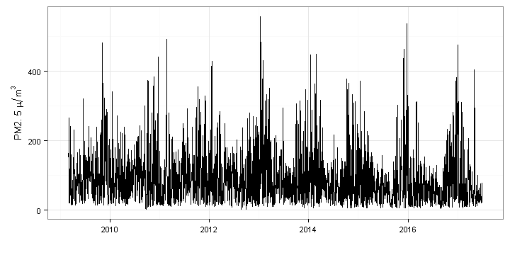Figure 1. Beijing PM2.5 levels 2009-2017 (US Embassy monitoring station)

## Modelling framework

Let be a complete filtered probability space for a fixed time horizon T. We denote the pollutant concentration level at time by , and describe the dynamics with

(4)

where is a deterministic seasonal trend function and is a stochastic process modelling the random fluctuations in the pollution level. From the plot above we see it might be reasonable to implement a trend function of the form

(5)

where t denotes the date, and (neglecting leap years). This allows us to capture the seasonal variations in ambient air pollution, which typically peaks during the winter season. The peak will not necessarily arise mid-winter, in January. This is handled by introducing a phase angle, D. Potential long term trends can be reflected in the drift term, B. We will explore alternative models for the stochastic part

Zero mean Ornstein-Uhlenbeck model

One-factor mean-reversion jump-diffusion model

Factor model

## Parameter estimation

To estimate the parameters, we reformulate the seasonality function as

(6)

Where the constants in (5) can be obtained by

(7)

(8)

(9)

(10)

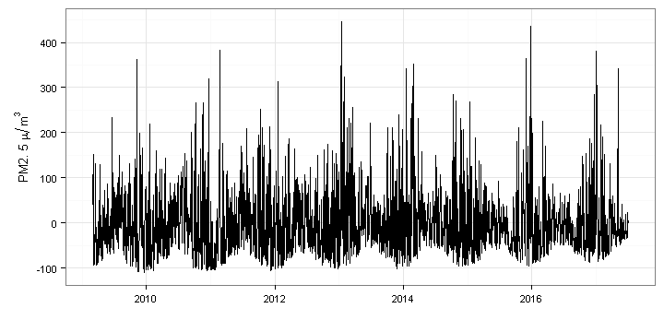

Figure 2. Deseasonalized Beijing PM2.5 levels

# Derivatives pricing

## Air pollution index futures

## Pricing options on air pollution futures

# Empirical results

## Data

## Analysis

# Conclusions

# Acknowledgments

References